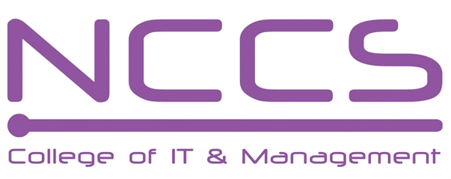
National College of Computer Studies
(NCCS-College of IT & Management)

Final Examination (2019)
BSc.CSIT/First Semester/ CSC – 110 : C Programming

Candidates are required to answer the questions in their own words as far as practicable.

Full Marks: 60
Pass Marks: 30
Time: 3 Hours
Set A

Attempt any Two Questions [2×10=20]
- Differentiate structure with union? Design a structure book with data members title, author, and cost. Write a main program in C to read detail of 10 books and find total cost and then display detail of books and total cost. [4+6]
- What is function? Explain its advantages. Explain the difference between passing arguments by value and passing arguments by address with suitable program. [4+6]
- Why data file is needed? Explain fscanf () and fprintf() function: Write a program to write N numbers in data file “number,txt” and then read its content and write all odd numbers in file “odd.txt” and all even numbers in “even.txt”. [1+3+6]

Attempt any Eight Questions. [8×5=40]
- What is an algorithm? List its properties. Explain the compilation and execution of any C
program. [1+1+3=5]
- Explain the switch statement with suitable example. [5]
- What is loop? Differentiate while and do while loop with suitable example. [2+3=5]
- “Size of a character array is one more than the input size”. Justify the statement. Write a program to read character array (String) and count numbers of words. [1+4=5]
- What is an array? Write a program to sort the numbers {12,4,56,2,8,76,11,99,1}in ascending order.[1+4=5]
- What is recursion? Explain with suitable example. [2+3=5]
- How an one dimensional array can be passed as function argument? Explain with suitable example. [2+3=5]
- Explain the use of graphical functions. Write a program to draw rectangle using graphics function. [1+4=5]
- Explain type conversion in C with suitable example. [5]

******


National College of Computer Studies
(NCCS-College of IT & Management)

Final Examination (2019)
BSc.CSIT/First Semester/ CSC – 110 : C Programming

Candidates are required to answer the questions in their own words as far as practicable.

Full Marks: 60
Pass Marks: 30
Time: 3 Hours
Set B

Attempt any Two Questions [2×10=20]
- What is debugging? Explain different types of programming errors. Describe the basic structure of C program with suitable example. [4+6]
- What is loop? Explain different types of loop with suitable example. [10]
- What is structure? How it differ from array? Design a structure student having data members roll, name, and mark in c. Write a main program in C to read detail of 20 students and then display detail of those students with mark greater than or equal to 80. [1+3+6]

Attempt any Eight Questions [8×5=40]
- What is flowchart? List different symbols used in flowchart. Draw a flowchart to find factorial of a
number. [1+2+2=5]
- Define nested if else statement with suitable flowchart. Write a program to check whether a number is divisible by 7 or 11 using nested if else statement. [2+3=5]
- Explain logical operators with truth table. Write a program to compute sum of square of first N natural number using do while loop. [2+3=5]
- List the string functions in C. Write a program to check whether a word is palindrome or not using. [1+4=5]
- How an one dimensional array can be initialized. Write a program to read N different numbers and find the smallest one. [2+3=5]
- Explain formulated I/O function in C with examples. [5]
- Explain function call by value and function call by reference with suitable example. [5]
- How a graphics driver can be initialized? Write a program to draw a triangle using line() function. [1+4=5]
- Write a short notes on: [2.5+2.5=5]
- Static local variable
- DMA

******

